Circle–Circle Tangency

Definition
# Source: AI Source: Provided by: [Data Path: Persons Table -> ID Column: 1, Name_En Column: Motasem Essam] -> From: [ChatGPT] on [7/25/2026]
Circle–Circle Tangency is the relationship in which two circles touch each other at exactly one common point.
That common point is called the Tangency Point or Point of Tangency.
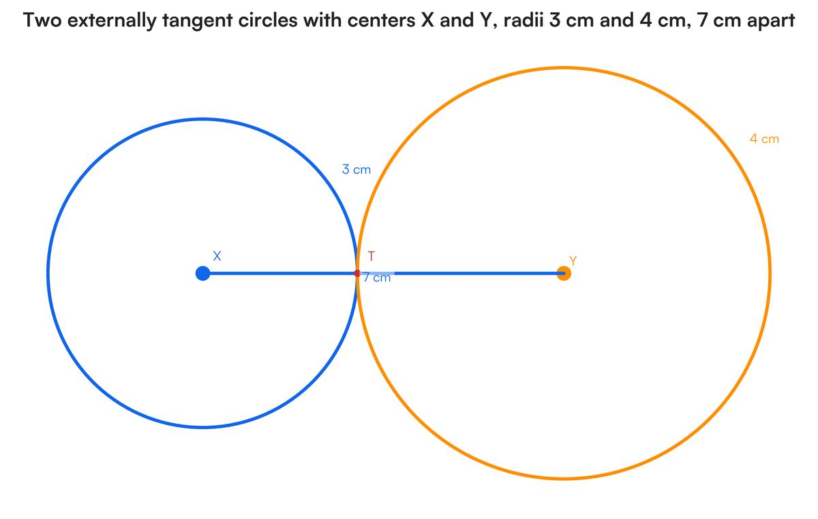
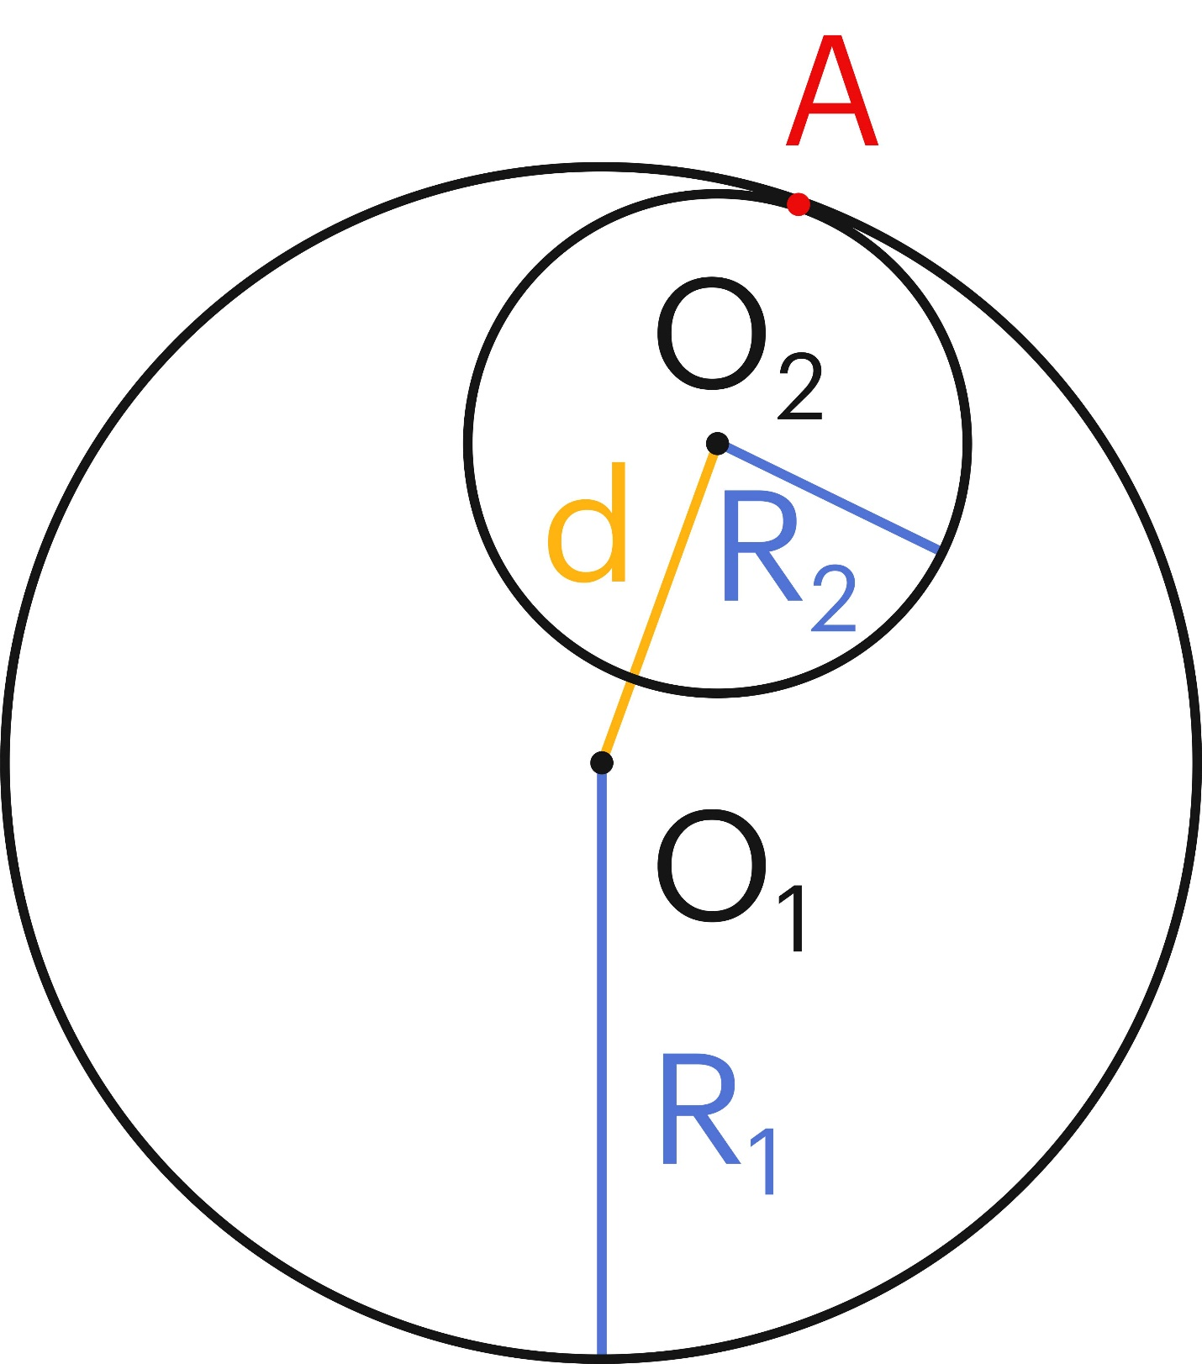
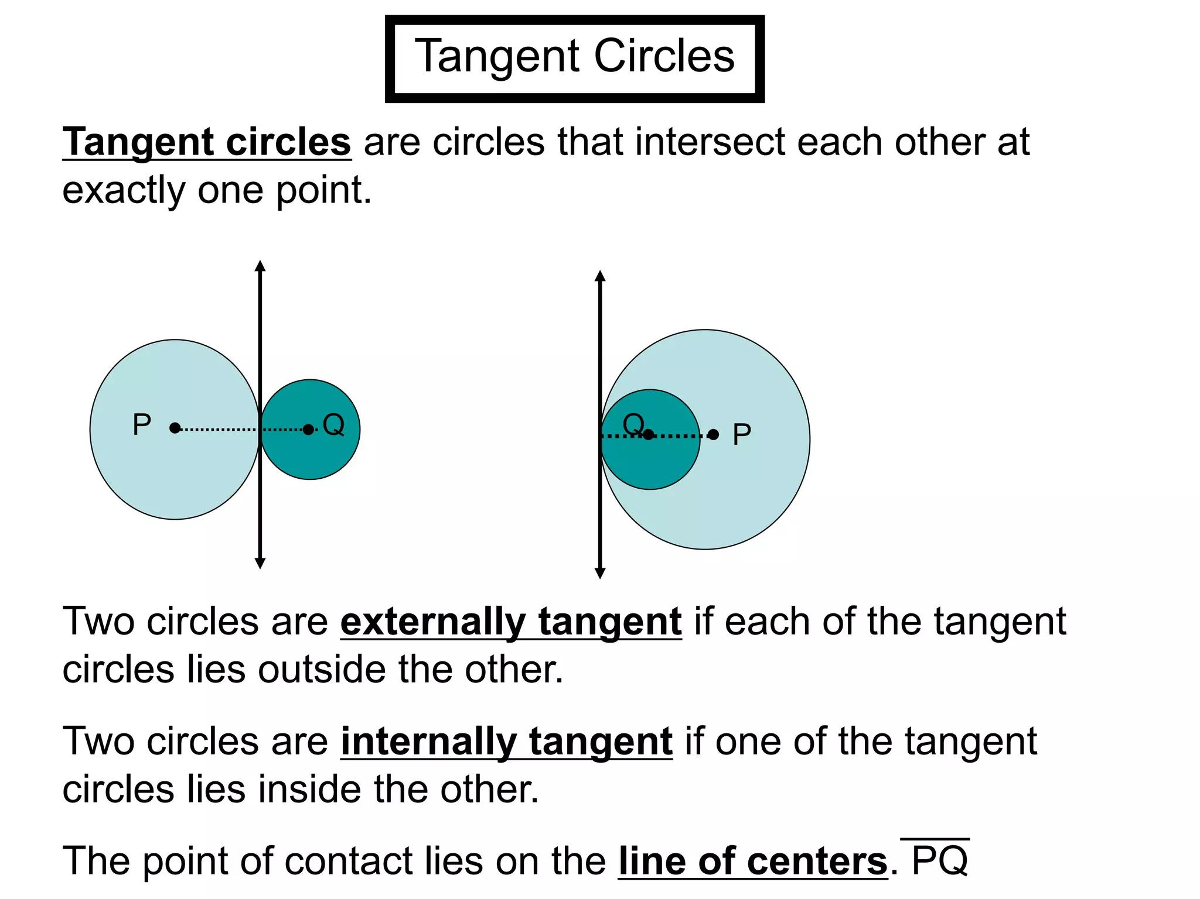
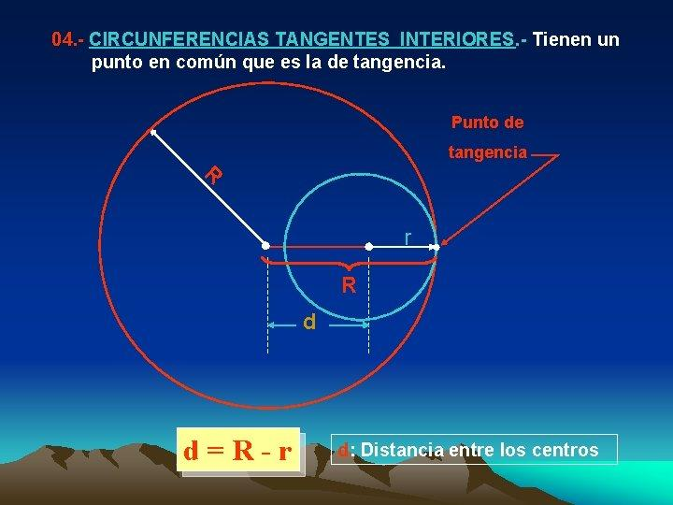

Fundamental Concept
# Source: AI Source: Provided by: [Data Path: Persons Table -> ID Column: 1, Name_En Column: Motasem Essam] -> From: [ChatGPT] on [7/25/2026]
Consider two circles:
- Circle $C_{1}$with center $O_{1}$and radius $R_{1}$
- Circle $C_{2}$with center $O_{2}$and radius $R_{2}$
- $T$= tangency point
For tangent circles:
$$\boxed{C_{1}∩C_{2}=\left\{T\right\}}$$
Thus, the two circles have exactly one common point.
The centers and the tangency point are always collinear:
$$\boxed{O_{1}, T, O_{2}\text{ are collinear}}$$

Types of Circle–Circle Tangency
# Source: AI Source: Provided by: [Data Path: Persons Table -> ID Column: 1, Name_En Column: Motasem Essam] -> From: [ChatGPT] on [7/25/2026]

Circle–Circle Tangency
├── External Tangency
└── Internal Tangency
The two types are distinguished by whether the circles touch from outside or from inside.

External Circle–Circle Tangency
# Source: AI Source: Provided by: [Data Path: Persons Table -> ID Column: 1, Name_En Column: Motasem Essam] -> From: [ChatGPT] on [7/25/2026]
External Tangency occurs when two circles touch from the outside, with neither circle lying inside the other.
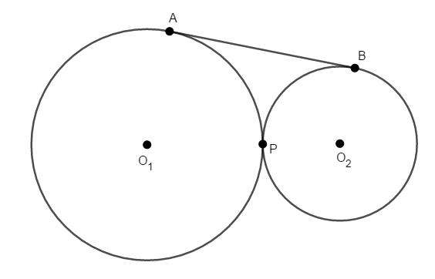
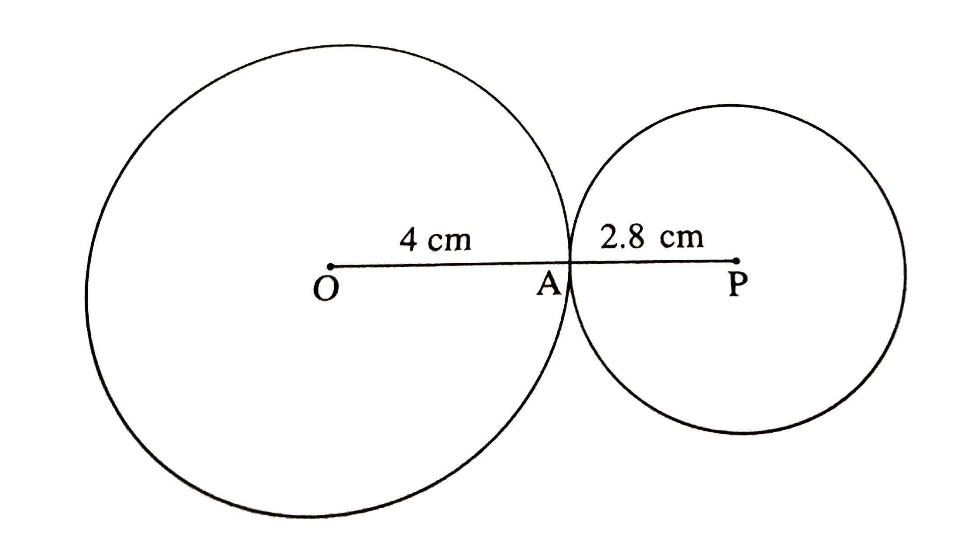
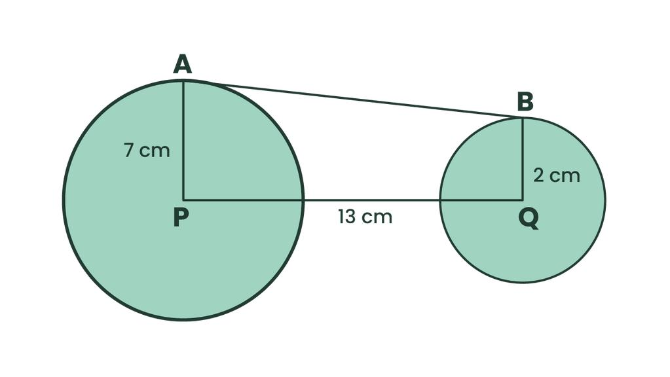
If the circles have radii $R_{1}$and $R_{2}$:
$$\boxed{O_{1}O_{2}=R_{1}+R_{2}}$$
The distance between the centers equals the sum of the radii.
At the Tangency Point
$$O_{1}T=R_{1} \\ O_{2}T=R_{2}$$
Therefore:
$$O_{1}T+TO_{2}=R_{1}+R_{2}$$
and hence:
$$\boxed{O_{1}O_{2}=R_{1}+R_{2}}$$
Example
If:
$$R_{1}=5\text{ cm}$$
and:
$$R_{2}=3\text{ cm}$$
then:
$$O_{1}O_{2}=5+3 \\ \boxed{O_{1}O_{2}=8\text{ cm}}$$

Internal Circle–Circle Tangency
# Source: AI Source: Provided by: [Data Path: Persons Table -> ID Column: 1, Name_En Column: Motasem Essam] -> From: [ChatGPT] on [7/25/2026]
Internal Tangency occurs when one circle lies inside the other and the two circles touch at exactly one point.
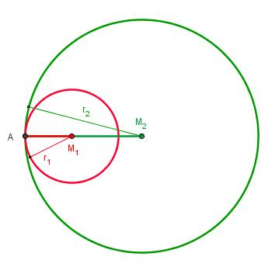
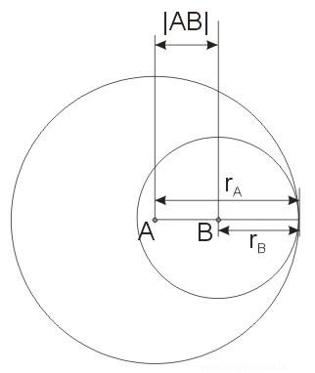
If the larger circle has radius $R$and the smaller circle has radius $r$, then:
$$\boxed{O_{1}O_{2}=R-r}$$
More generally:
$$\boxed{O_{1}O_{2}=∣R_{1}-R_{2}∣}$$
The distance between the centers equals the difference between the radii.

Position of the Tangency Point
# Source: AI Source: Provided by: [Data Path: Persons Table -> ID Column: 1, Name_En Column: Motasem Essam] -> From: [ChatGPT] on [7/25/2026]
For both external and internal tangency:
$$\boxed{O_{1}, T, O_{2}\text{ are collinear}}$$
This means that the line connecting the two centers passes directly through the tangency point.
External Tangency
O₁ ─────── T ─────── O₂
R₁ R₂
Internal Tangency
O₁ ─── O₂ ─── T
r R-r
The exact order depends on which circle is larger and how the circles are positioned.

Common Tangent at the Tangency Point
# Source: AI Source: Provided by: [Data Path: Persons Table -> ID Column: 1, Name_En Column: Motasem Essam] -> From: [ChatGPT] on [7/25/2026]
At the tangency point $T$, the two circles have the same tangent line.
The common tangent is perpendicular to the line joining the centers:
$$\boxed{l⊥O_{1}O_{2}}$$
Therefore:
$$\boxed{l⊥O_{1}T}$$
and:
$$\boxed{l⊥O_{2}T}$$
This is because both $O_{1}T$and $O_{2}T$are radii.

External vs. Internal Tangency
# Source: AI Source: Provided by: [Data Path: Persons Table -> ID Column: 1, Name_En Column: Motasem Essam] -> From: [ChatGPT] on [7/25/2026]
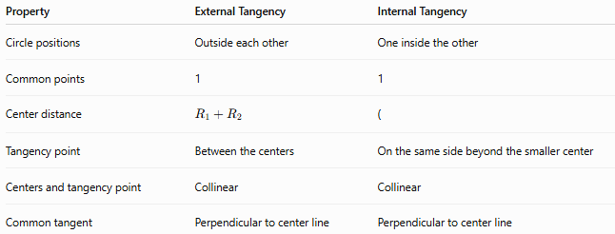
Property | External Tangency | Internal Tangency
Circle positions | Outside each other | One inside the other
Common points | 1 | 1
Center distance | $$R_{1}+R_{2}$$ | (
Tangency point | Between the centers | On the same side beyond the smaller center
Centers and tangency point | Collinear | Collinear
Common tangent | Perpendicular to center line | Perpendicular to center line

Circle–Circle Position Classification
# Source: AI Source: Provided by: [Data Path: Persons Table -> ID Column: 1, Name_En Column: Motasem Essam] -> From: [ChatGPT] on [7/25/2026]
The relationship between two circles can be determined using the center distance $d$.
Let:
$$d=O_{1}O_{2}$$
and assume:
$$R_{1}≥R_{2}$$
Then:
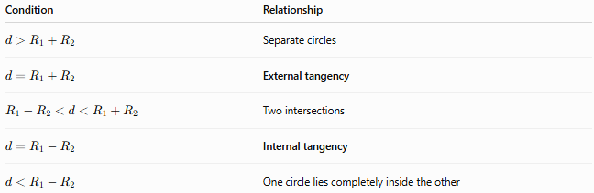
Condition | Relationship
$$d>R_{1}+R_{2}$$ | Separate circles
$$d=R_{1}+R_{2}$$ | External tangency
$$R_{1}-R_{2}<d<R_{1}+R_{2}$$ | Two intersections
$$d=R_{1}-R_{2}$$ | Internal tangency
$$d<R_{1}-R_{2}$$ | One circle lies completely inside the other
Thus the two tangency conditions are:
$$\boxed{d=R_{1}+R_{2}}$$
for external tangency, and:
$$\boxed{d=∣R_{1}-R_{2}∣}$$
for internal tangency.

Example — External Tangency
# Source: AI Source: Provided by: [Data Path: Persons Table -> ID Column: 1, Name_En Column: Motasem Essam] -> From: [ChatGPT] on [7/25/2026]
Two circles have radii:
$$R_{1}=10\text{ cm}$$
and:
$$R_{2}=6\text{ cm}$$
If they are externally tangent:
$$O_{1}O_{2}=R_{1}+R_{2} \\ O_{1}O_{2}=10+6 \\ \boxed{O_{1}O_{2}=16\text{ cm}}$$

Example — Internal Tangency
# Source: AI Source: Provided by: [Data Path: Persons Table -> ID Column: 1, Name_En Column: Motasem Essam] -> From: [ChatGPT] on [7/25/2026]
A large circle has radius:
$$R=12\text{ cm}$$
and a smaller circle has radius:
$$r=5\text{ cm}$$
For internal tangency:
$$O_{1}O_{2}=R-r \\ O_{1}O_{2}=12-5 \\ \boxed{O_{1}O_{2}=7\text{ cm}}$$

Special Case — Equal Circles
# Source: AI Source: Provided by: [Data Path: Persons Table -> ID Column: 1, Name_En Column: Motasem Essam] -> From: [ChatGPT] on [7/25/2026]
If:
$$R_{1}=R_{2}$$
then internal tangency would require:
$$O_{1}O_{2}=∣R_{1}-R_{2}∣=0$$
which means the centers coincide.
That does not produce two distinct internally tangent circles. Therefore, two distinct equal circles can be externally tangent, but they cannot be internally tangent in the ordinary sense.
For equal circles with external tangency:
$$\boxed{O_{1}O_{2}=2R}$$

Tangency and Common Chords
# Source: AI Source: Provided by: [Data Path: Persons Table -> ID Column: 1, Name_En Column: Motasem Essam] -> From: [ChatGPT] on [7/25/2026]
Two non-tangent circles intersect at two points and have a common chord.
When the circles become tangent, the two intersection points merge into a single point:
$$\boxed{T}$$
Thus, the tangency point can be viewed as the limiting common point of the two circles.

Coordinate Geometry
# Source: AI Source: Provided by: [Data Path: Persons Table -> ID Column: 1, Name_En Column: Motasem Essam] -> From: [ChatGPT] on [7/25/2026]
For two circles with centers:
$$O_{1}\left(x_{1} , y_{1}\right)$$
and:
$$O_{2}\left(x_{2} , y_{2}\right)$$
their center distance is:
$$\boxed{d=\sqrt{{\left(x_{2}-x_{1}\right)}^{2}+{\left(y_{2}-y_{1}\right)}^{2}}}$$
External Tangency
$$\boxed{\sqrt{{\left(x_{2}-x_{1}\right)}^{2}+{\left(y_{2}-y_{1}\right)}^{2}}=R_{1}+R_{2}}$$
Internal Tangency
$$\boxed{\sqrt{{\left(x_{2}-x_{1}\right)}^{2}+{\left(y_{2}-y_{1}\right)}^{2}}=∣R_{1}-R_{2}∣}$$

Tangency Point Coordinates
# Source: AI Source: Provided by: [Data Path: Persons Table -> ID Column: 1, Name_En Column: Motasem Essam] -> From: [ChatGPT] on [7/25/2026]
Because $O_{1}$, $T$, and $O_{2}$are collinear, the tangency point lies on the line joining the centers.
For external tangency, the point $T$divides $O_{1}O_{2}$internally in the ratio:
$$R_{1}:R_{2}$$
If:
$$O_{1}=\left(x_{1} , y_{1}\right)$$
and:
$$O_{2}=\left(x_{2} , y_{2}\right)$$
then:
$$\boxed{T=\left(\frac{R_{2}x_{1}+R_{1}x_{2}}{R_{1}+R_{2}} , \frac{R_{2}y_{1}+R_{1}y_{2}}{R_{1}+R_{2}}\right)}$$
for external tangency.

Important Properties
# Source: AI Source: Provided by: [Data Path: Persons Table -> ID Column: 1, Name_En Column: Motasem Essam] -> From: [ChatGPT] on [7/25/2026]
- Two tangent circles have exactly one common point.
- The common point is the tangency point.
- The two centers and tangency point are collinear.
- The common tangent at the tangency point is perpendicular to the line joining the centers.
- External tangency gives:
$$d=R_{1}+R_{2}$$
- Internal tangency gives:
$$d=∣R_{1}-R_{2}∣$$
- Externally tangent circles lie outside each other.
- Internally tangent circles have one circle inside the other.
- Two distinct equal circles can be externally tangent but not internally tangent.
- Tangency means there is exactly one common point, rather than two intersection points.

Classification Tree
# Source: AI Source: Provided by: [Data Path: Persons Table -> ID Column: 1, Name_En Column: Motasem Essam] -> From: [ChatGPT] on [7/25/2026]
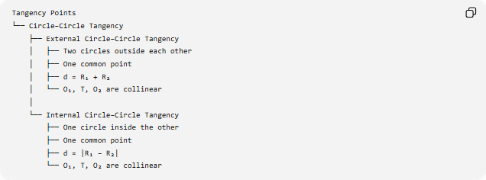
Tangency Points
└── Circle–Circle Tangency
├── External Circle–Circle Tangency
│ ├── Two circles outside each other
│ ├── One common point
│ ├── d = R₁ + R₂
│ └── O₁, T, O₂ are collinear
│
└── Internal Circle–Circle Tangency
├── One circle inside the other
├── One common point
├── d = |R₁ − R₂|
└── O₁, T, O₂ are collinear

Key Formulas
# Source: AI Source: Provided by: [Data Path: Persons Table -> ID Column: 1, Name_En Column: Motasem Essam] -> From: [ChatGPT] on [7/25/2026]
External tangency:
$$\boxed{d=R_{1}+R_{2}}$$
Internal tangency:
$$\boxed{d=∣R_{1}-R_{2}∣}$$
Center distance:
$$\boxed{d=\sqrt{{\left(x_{2}-x_{1}\right)}^{2}+{\left(y_{2}-y_{1}\right)}^{2}}}$$
Collinearity:
$$\boxed{O_{1}, T, O_{2}\text{ are collinear}}$$
Common tangent:
$$\boxed{l⊥O_{1}O_{2}}$$

Conclusion
# Source: AI Source: Provided by: [Data Path: Persons Table -> ID Column: 1, Name_En Column: Motasem Essam] -> From: [ChatGPT] on [7/25/2026]
Circle–Circle Tangency occurs when two circles touch at exactly one point. It has two fundamental types:
- External Tangency — the circles touch from outside, with $d=R_{1}+R_{2}$.
- Internal Tangency — one circle lies inside the other and they touch internally, with $d=∣R_{1}-R_{2}∣$.
In both cases, the two centers and the tangency point lie on the same straight line.

